
Application Instructions
When using DETOUR for Rodents follow these Guide lines
DeTour for Rodents is a CONTACT repellent. DeTour will not harm rodents. It is a contact irritant. In order for it to work it must be placed in areas where rodents will come in contact with it and get the product on them. Once a Rodent has come in contact with the product they will avoid the area and may leave the structure entirely.
DeTour for Rodents also elicits a stress response that will lower the rodents’ normal shyness to new things and can enhance the operation of current rodent mechanical traps and baits.
Most on-going rodent control programs are static- relying on mechanical devices or baits set at regular intervals. DeTour is dynamic – the user needs to think their way through the application, consider all the dynamics and develop a strategy to force the rodents to come in contact with the product to either drive rodents away from the structure or use the product in combination with existing equipment to enhance the current program.
DeTour for Rodents is the first product that uses the actual rodent as the delivery system. Rodents that contact the product take the DeTour back to their nesting sites thereby infecting the other rodents and forcing them from their living and hiding areas. No other product does this.

Application Cautions

Make sure DeTour is never placed in areas where humans may accidentally come in contact with the product. The active ingredient, White Pepper, may cause a reddening of the skin or eye irritation.

Applicators should wear latex gloves when applying DeTour. Any product that contacts the skin should be removed by immediately washing the affected area with soap and water or through the use of baby wipes or other alcohol-based wipes.

General Use Instructions
(Specific strategies for the use of DeTour are outlined below!)

DETOUR for Rodents must be placed in the direct path of Rodents where contact will occur. Look for areas of rodent activity including locations where droppings, rub marks or gnaw marks are visible and place DeTour in the path of the rodents.
DETOUR may be used in any of the locations listed as long as placements are in areas where people or pets will not contact the applied material.
- Kitchens
- Food storage areas
- Behind fixtures
- Underneath or Behind Cabinets
- Ceilings
- Attic Spaces
- Behind or Underneath Kitchen Equipment
- Inside voids/chases in walls, floors or ceilings
- Exterior perimeter at any potential entry point and along areas where rodents might travel
- Under Grocery Store Gondolas to create a rodent “no-Go Zone”
- Inject directly into inaccessible wall voids to drive rodents out of hiding.
- Areas where you see signs of activity include feces, urine trails and rub marks
- Around the base of trees
- Directly into Rodent Burrows
- Identify food sources and use DeTour to cut off rodents from the food source

Product Packaging Options
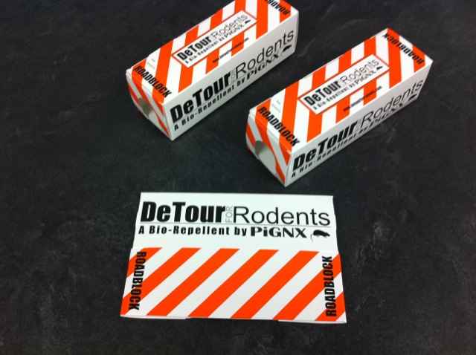
Roadblocks come pre-filled with ½ oz DeTour. They come folded flat and easily pop open into a box with openings on both ends for mouse entry. There are sticky pads on the bottom to attach to floors, walls, etc. The DeTour warning sign is printed on the box. Roadblocks are designed for placement anywhere there is the potential for people or animals to come in contact with the product

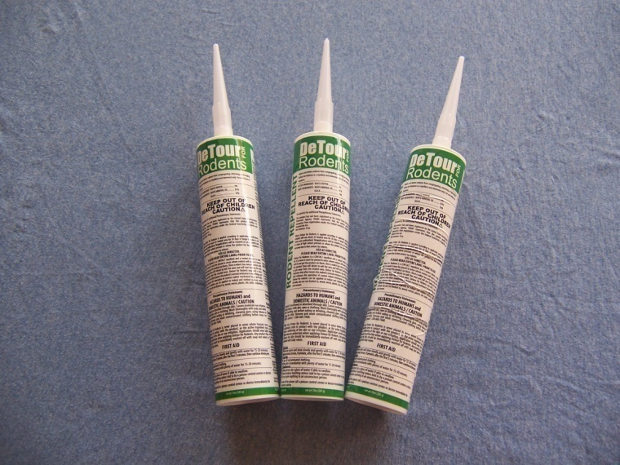
DeTour in the 10 Oz Tubes requires the use of a standard caulking gun

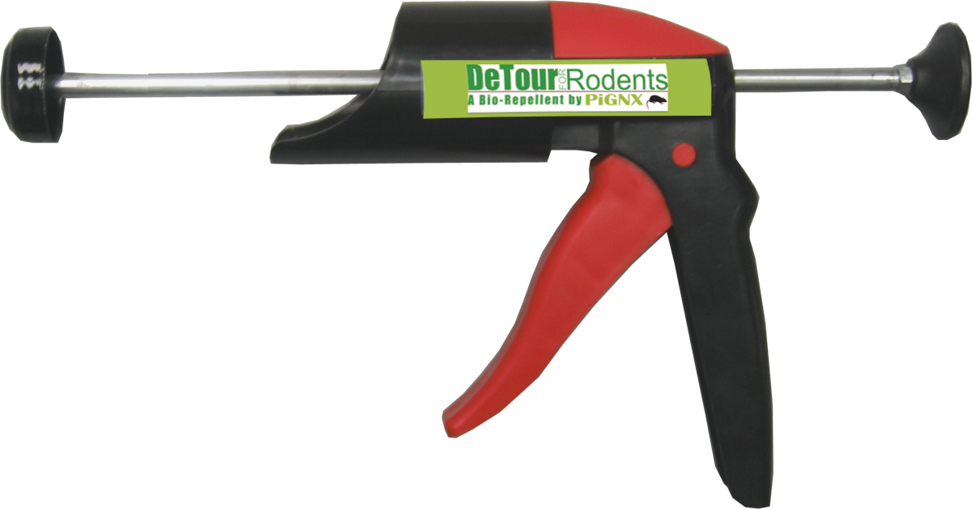

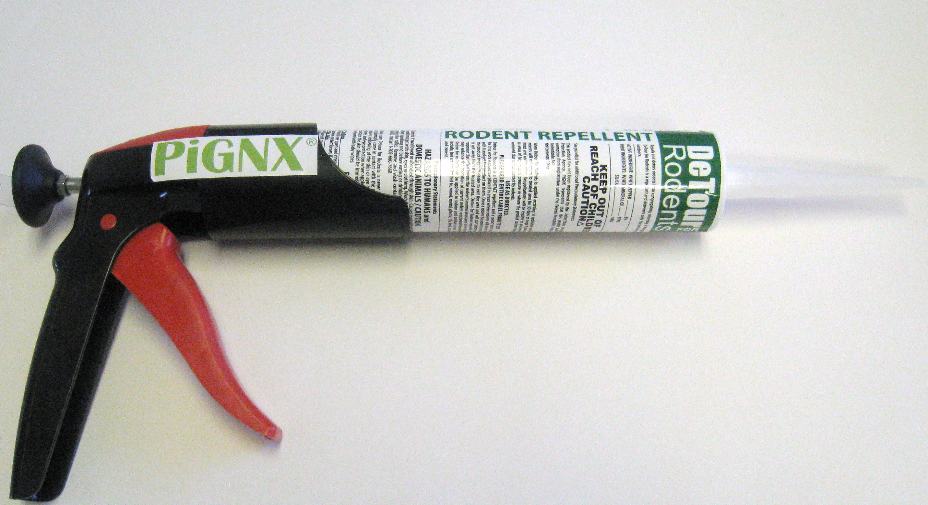

Bulk product may be applied using a bulk loading caulking gun for wall injection or bead application or using a paint brush or putty knife for a wider spreading option. You may also make your own trays using bulk DeTour with foam trays, plastic tray or similar materials.
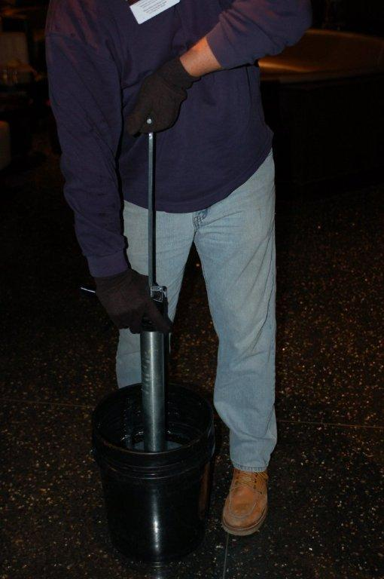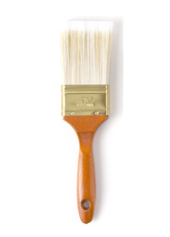

DeTour comes with warning stickers for you to place in areas where you use the product. Even though DeTour is harmless it can cause a reddening of the skin. We provide these stickers for you to inform your clients that the product is in place and to let them know what they need to do in case of contact.

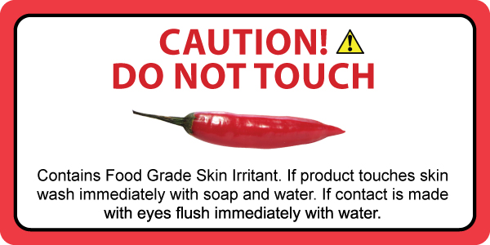

DETOUR for Rodents should or can be used with other rodent control products such as glue traps, snap traps and baits. DETOUR for Rodents can enhance their effectiveness.

Apply DETOUR for Rodents to visible rodent entry points in walls, ceilings and floors
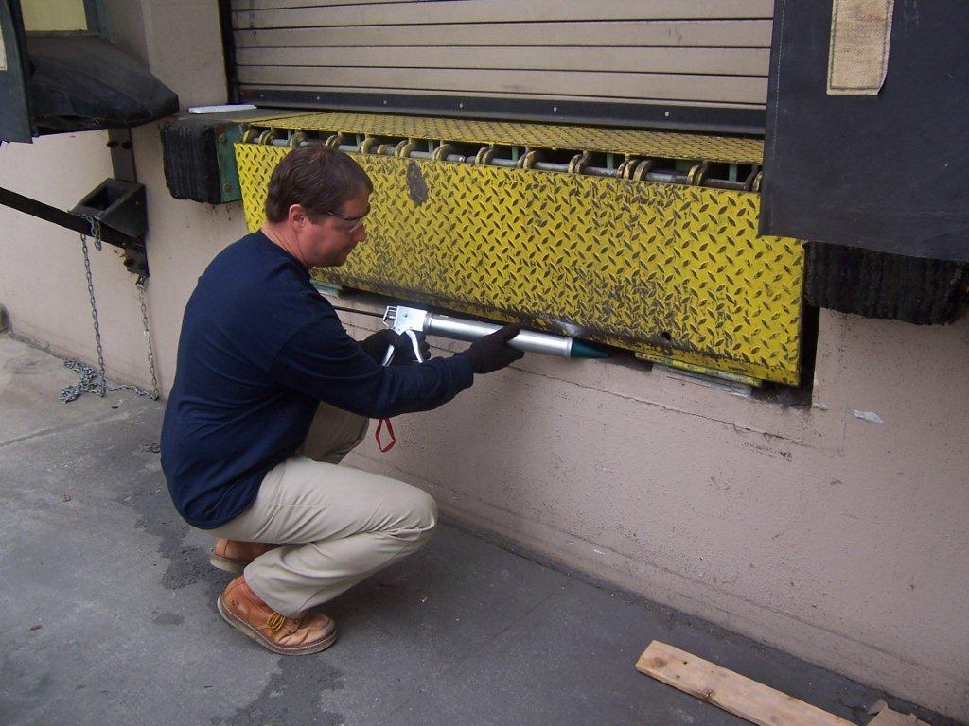

In Commercial Kitchens apply DETOUR for Rodents at ground level directly behind kitchen equipment so it cannot be scrubbed away or washed away easily. If product can be accessed by humans place in a tamper-resistant stations or use DeTour Roadblock or removable placements described below.
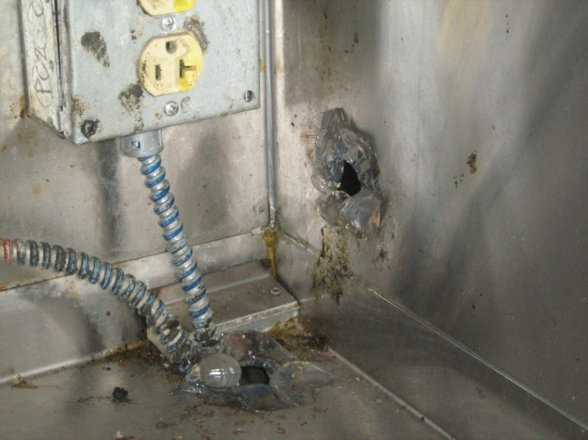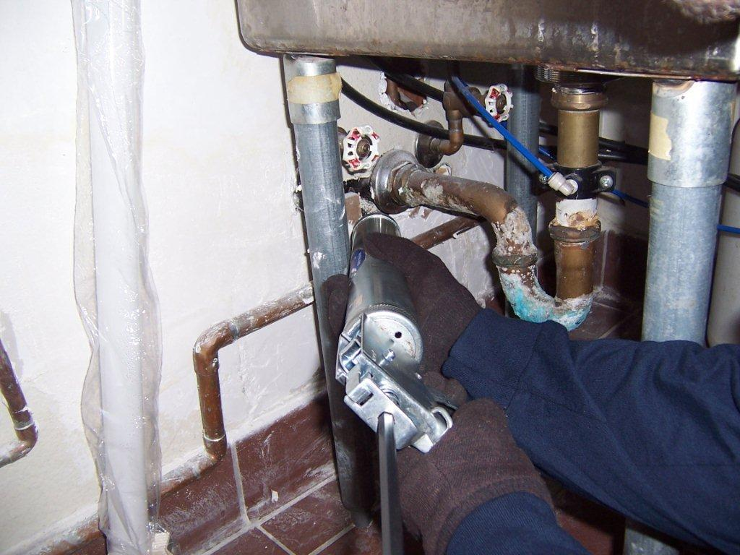
In machinery access panels apply DETOUR for Rodents around openings for plumbing, gas and electrical lines

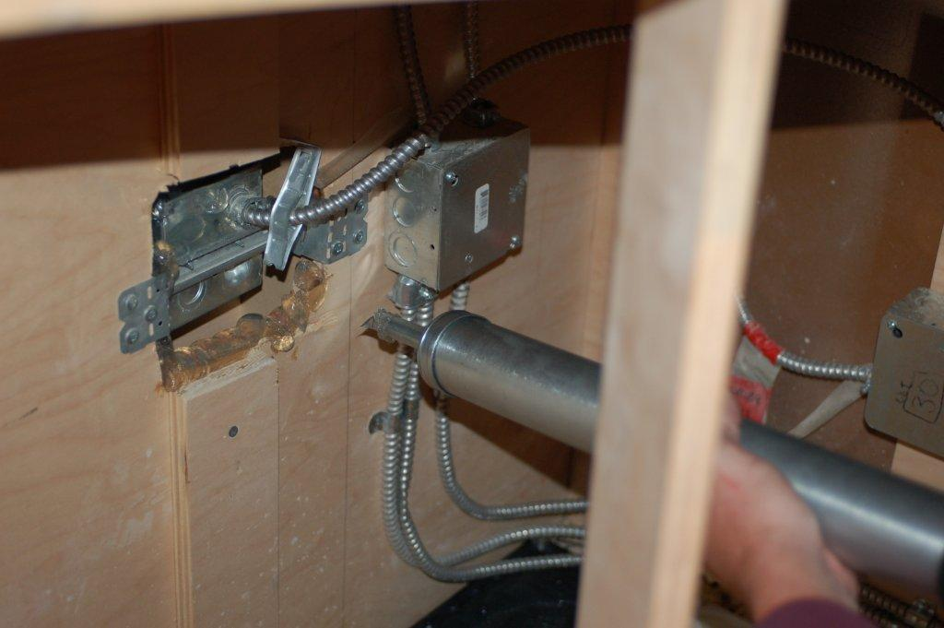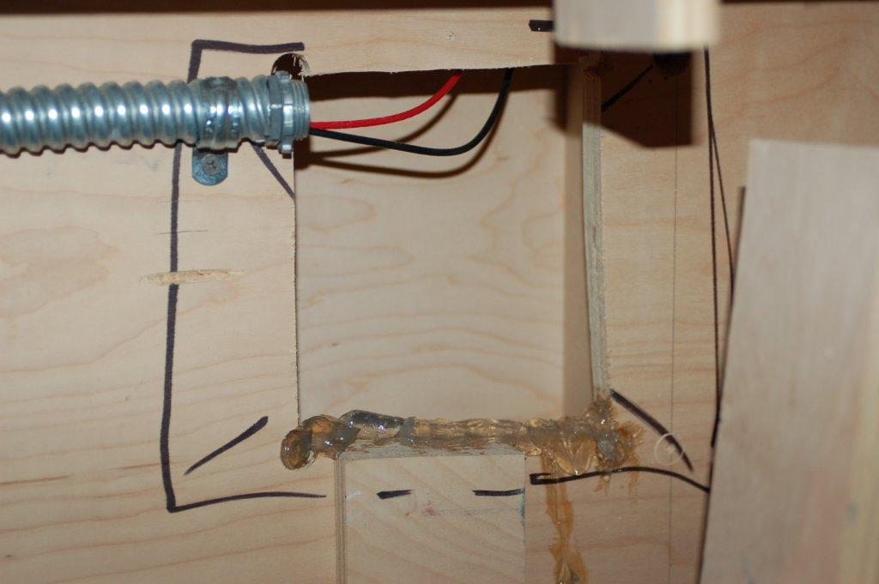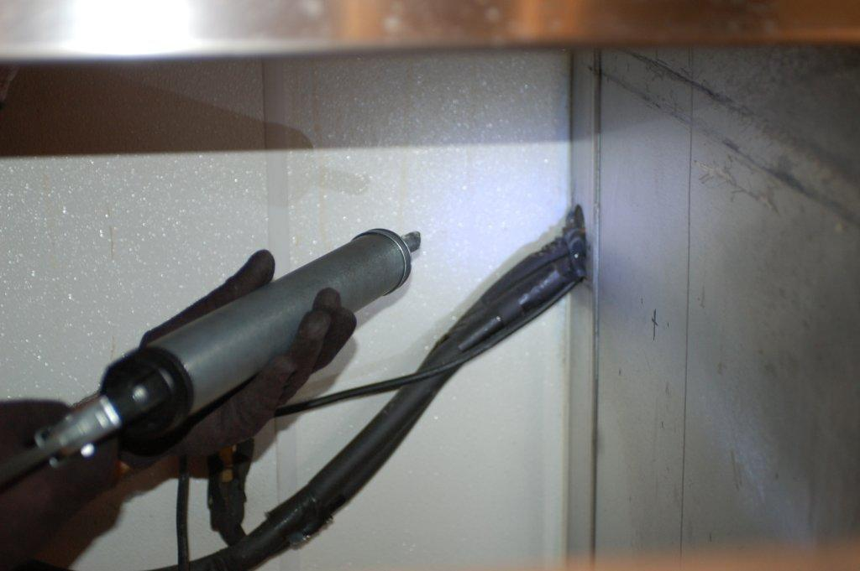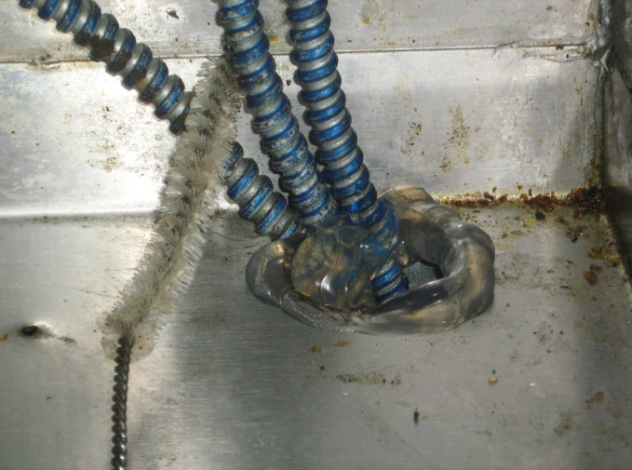

Apply DETOUR for Rodents to possible paths of travel such as interior perimeter walls, near door thresholds, at the base of columns. DETOUR for Rodents can also be brushed onto areas where a bead cannot be applied. A thick layer of DETOUR for Rodents will provide the best results.

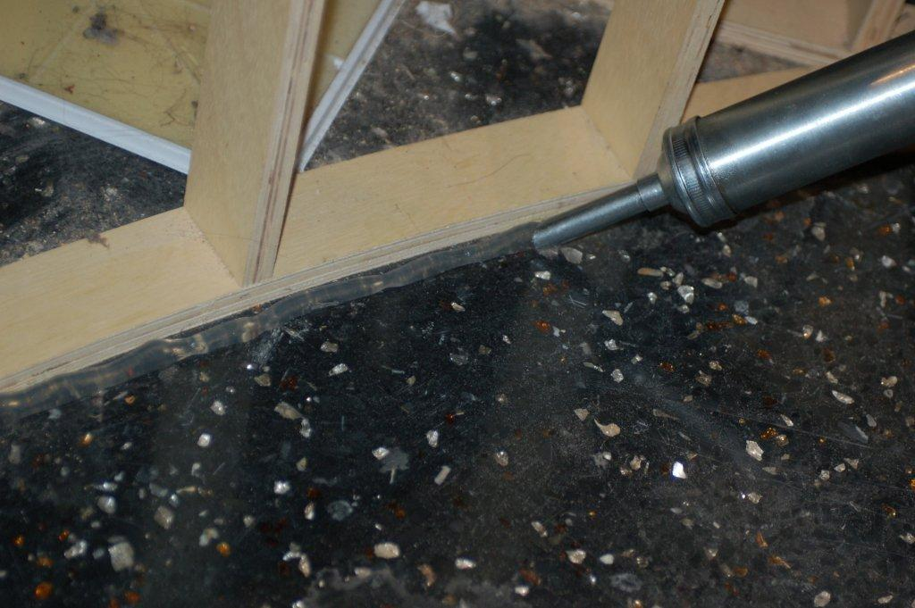

DeTour can be used in all inaccessible areas where other rodent equipment just won’t fit.
Use DeTour to drive rodents from these inaccessible areas.

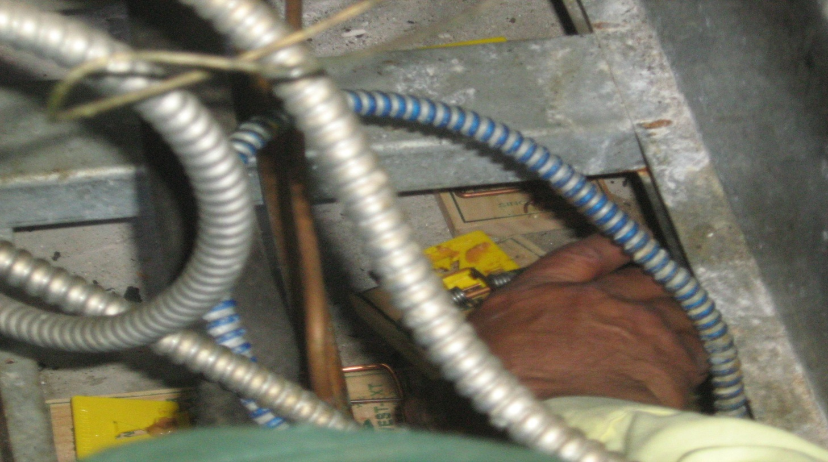

In T-Bar or Drop Ceilings- DETOUR for Rodents should also be applied to paths of travel above ceilings such as sprinkler lines, water lines, electrical pipes and gas lines. Use DeTour Roadblock or other temporary placements or apply with a paint brush for maximum coverage. Do not place directly on porous ceiling tiles as product may be absorbed by the tiles.
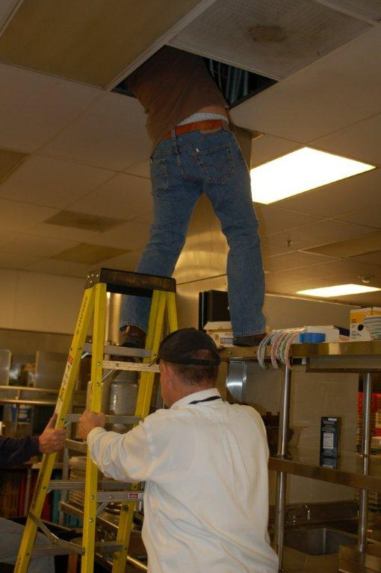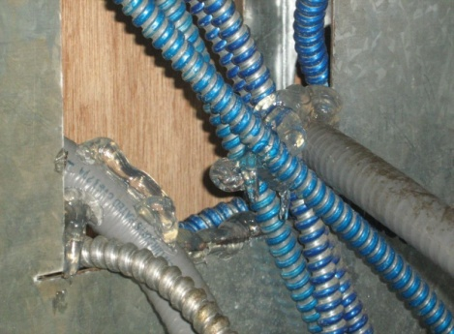
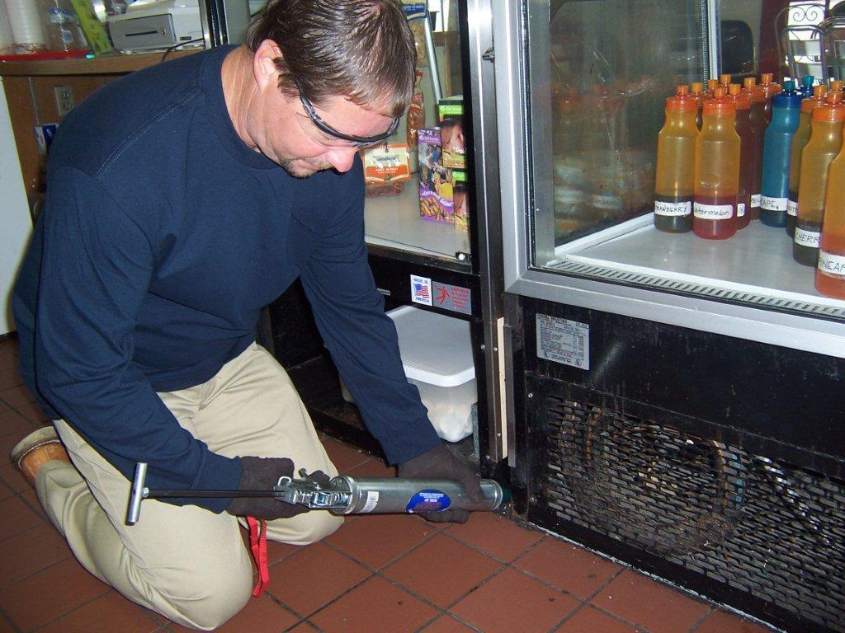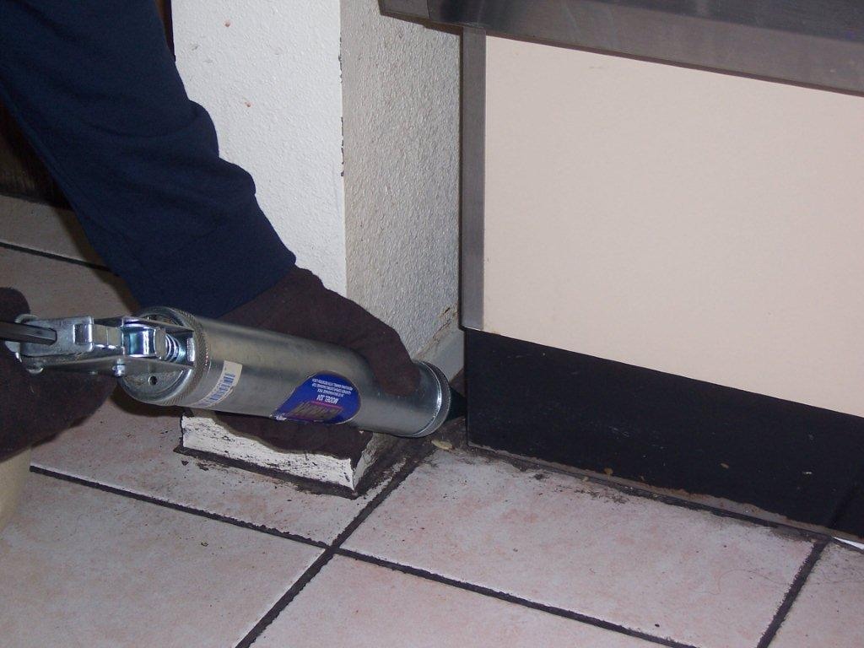

Specific Strategy Instructions
Rodent Infestations – Cleanouts
Use DeTour for Rodents in conjunction with a sound rodent eradication strategy. Apply DeTour for Rodents as described above to every conceivable area where rodents will contact the product. Make sure there is DeTour for Rodents a placement every 10 feet where practical to insure rodent contact. Use a combination of all the available product delivery systems.

Apply the DeTour for Rodents after hours in severely infested locations. Stressed rodents will become very active once exposed to the product and they will attempt to leave the structure. Make sure you have also developed a sound rodent management strategy that incorporates traps, glue boards and baits for the best results.

When the rodents are affected by contact with DeTour, they will attempt to leave the structure and can be caught in pre-positioned traps. Stressed rodents may also start to enter stations and consume baits they have previously avoided. Employ this strategy until control is achieved.

Rodent Management Programs
Use DeTour for Rodents to augment an existing rodent management program. Use as described above to repel rodents and to keep them moving enhancing the likelihood they will leave or be caught. Use as directed to prevent entrance into the structure.

Rodent Prevention Strategies
Use DeTour for Rodents around the exterior at any potential entry point. A bead of product around the exterior perimeter between the siding and the foundation can effectively prevent any rodent from entering the structure.



